Screen shot for the working RestAPI in Postman with Consumer Key, Consumer Secret , Access Token and Token Secret.
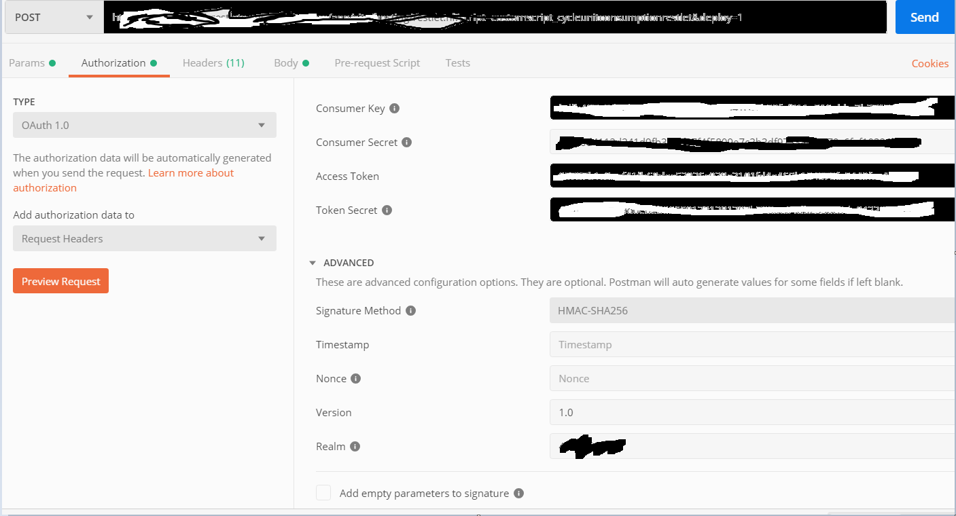

Screen shot for Snaplogic OAuth 1.0 account settings where we have Client ID, Client Secret but don’t have the Access Token and Token Secret.

