Do we need to set the password on the Account page? The Outlook Administrator is reluctant to share password for this settings.
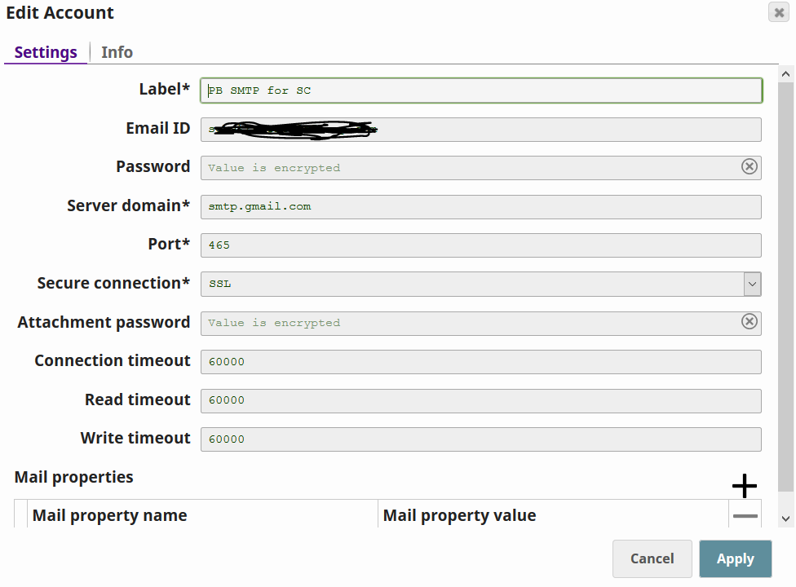

In the Email Sender page, we want to set the From field so that we can identify the Sender

