Generate SSH Key Pair with PuTTYgen

- Open the PuTTYgen application by double clicking on it
(download from https://www.chiark.greenend.org.uk/~sgtatham/putty/latest.html).
- Choose SSH-2 RSA for the Type of key to generate.
- Enter the desired Number of bits in a generated key.
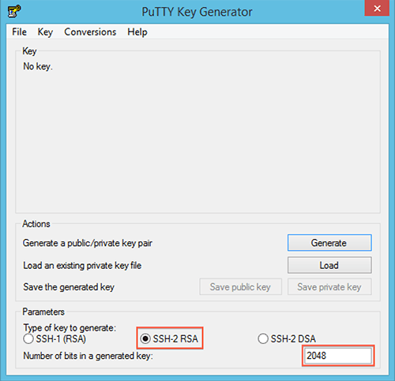
- Click the Generate button.
- Move your mouse around until the progress bar is full.
- You now will have a generated public and private key.
- Enter the Key comment and a Key passphrase
- Save the private and public key files to a location that only you can access and that you will not lose.
- Send the Public Key to the SFTP host
- The Private key saves as a PPK file. If you need a standard OpenSSH Private Key format for the SFTP client, click Conversions -> Export OpenSSH Key
- Store your keys and passphrase into the password/key vault

