Errors in Dashboard ---

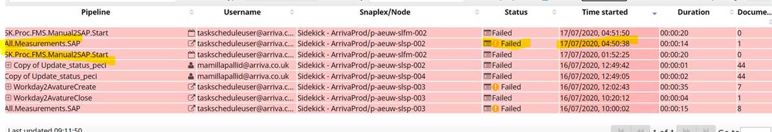

Snippet of failed area ..

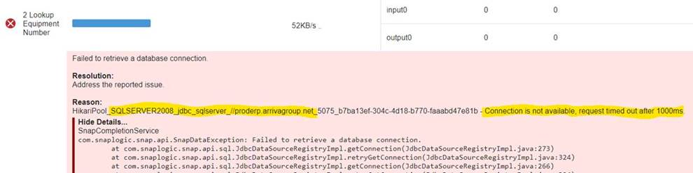

Current setting in SqlServer

