Sure, you can share the pipeline if you want, but I won’t be able to execute it against your account. It would probably be more useful to see the output of the NetSuite Search snap, and to know the scriptId of the custom field you’re looking for.

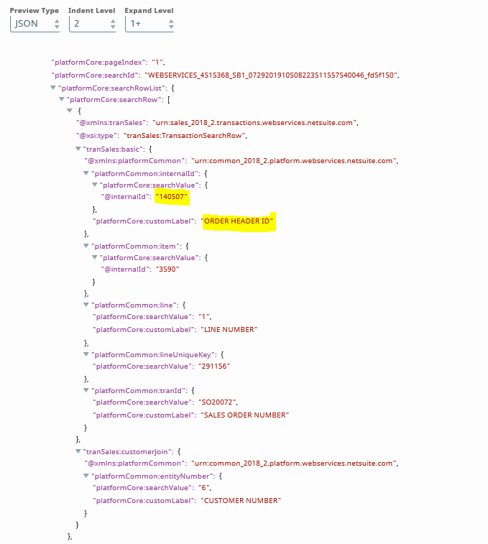

Screen shot for the saved search which Order Header Id and Console Serial Number. We are able to get the Order Header Id but not the Console Serial Number
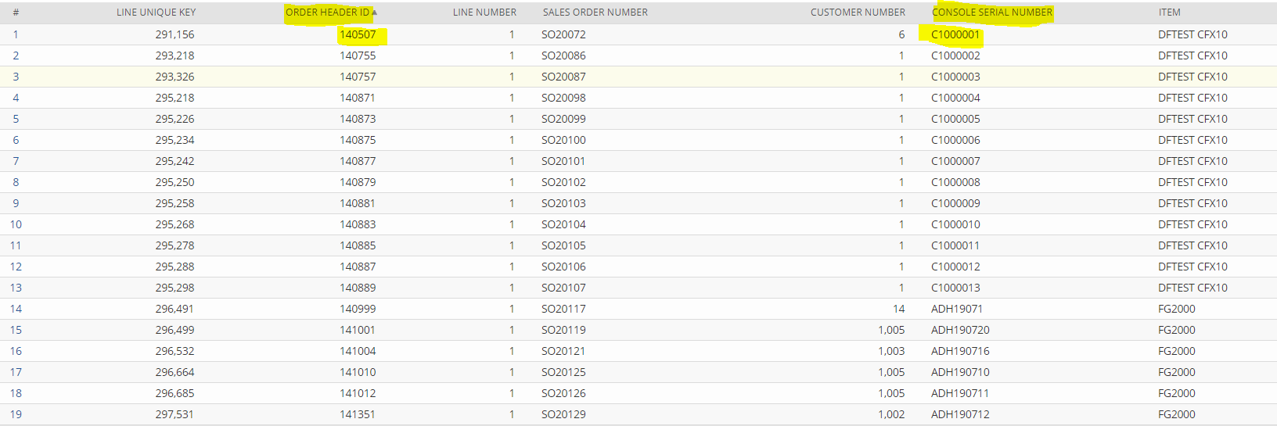

Custom field definition

{fulfillingtransaction.serialnumbers} ---- ConsoleId <=> READ FROM SAVED SEARCH FIELD “CONSOLE SERIAL NUMBER”

