Example using the Rest Get to retrieve course information I belong too:
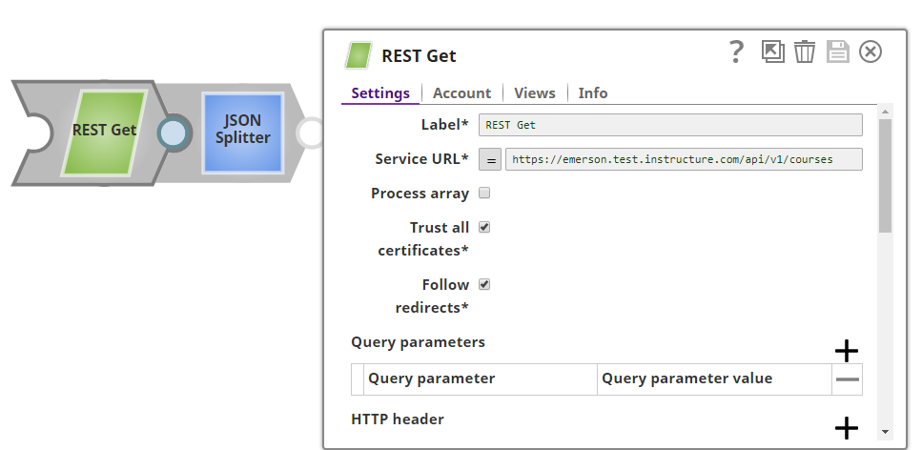

Using Account with a Bearer Token

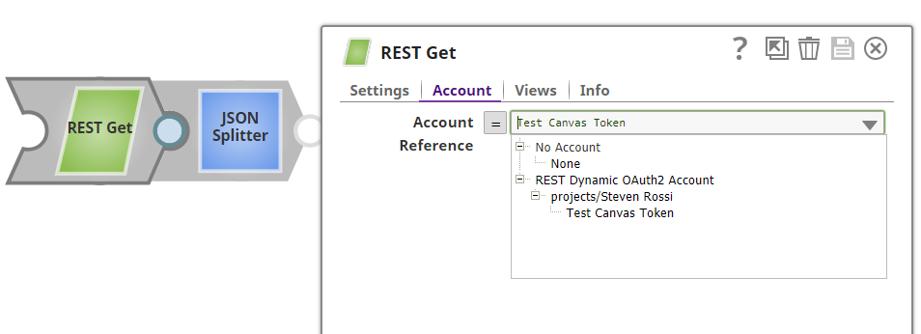

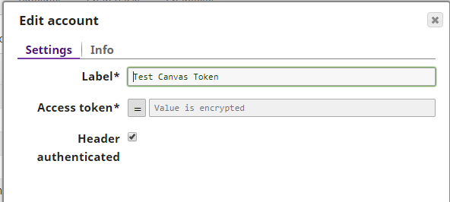

It returns the courses I belong too just fine:

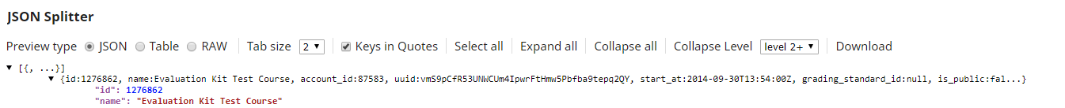

When trying to use the Rest Post I cannot get it to work. If I issue the following curl command on the O/S it loads the example user in my CSV just fine:
curl -F attachment=@users.csv -H "Authorization: Bearer <TOKEN > " 'https://emerson.test.instructure.com/api/v1/accounts/self/sis_imports.json?import_type=instructure_csv'

My REST Post looks like the following:
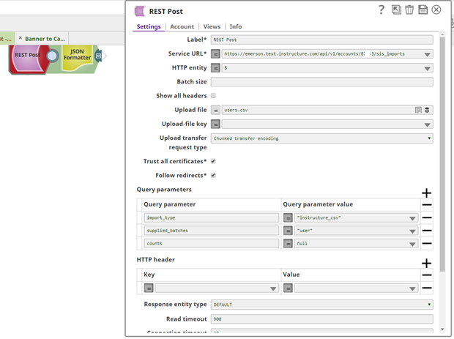

I am reading the CSV file I have on SnapLogic:
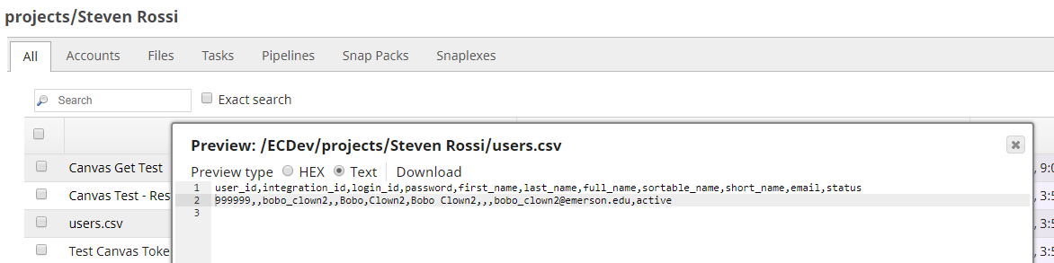

I am using the following URL, which discusses the API I am trying to use:
https://canvas.instructure.com/doc/api/sis_imports.html

The following is the error I get when trying to run it.
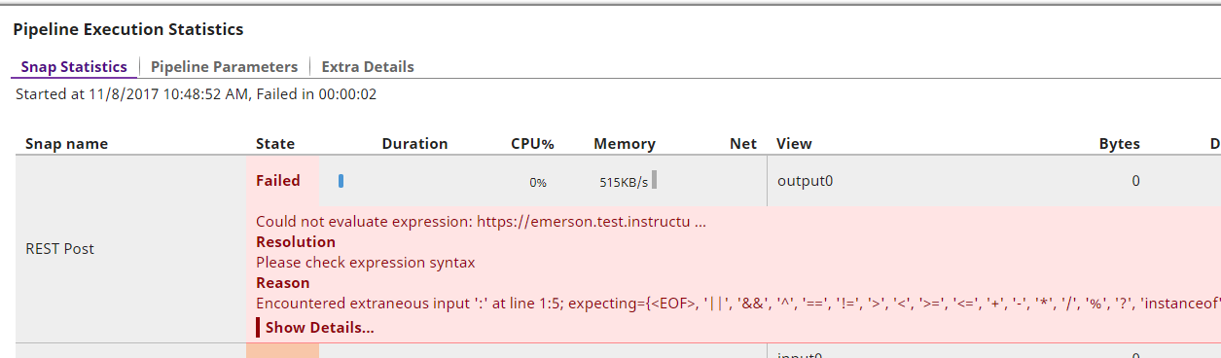

Help!

